NAME: GURUPRASATH.S
REG NO:192411270L
SUB NAME: COMPUTER VISION
SUB COD: ITA0502
EX NO:1
1. Convert an Image to Gray-Scale using Python
AIM:
To read an image in Python and convert the given color image into a gray-scale image using OpenCV.
ALGORITHM:
- Import the required OpenCV library.
- Read the input image using cv2.imread().
- Convert the color image into gray-scale using cv2.cvtColor().
- Display the original and gray-scale images.
- Save the gray-scale image if required.
PROGRAM:
import cv2
image = cv2.imread("imagess.jpg")
gray_image = cv2.cvtColor(image, cv2.COLOR_BGR2GRAY)
cv2.imshow("Original Image", image)
cv2.imshow("Gray-scale Image", gray_image)
cv2.waitKey(0)
cv2.destroyAllWindows()
SAMPLE INPUT:
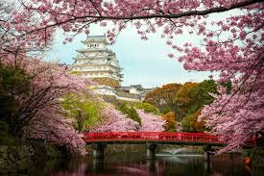

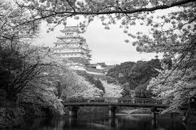
SAMPLE OUTPUT:

RESULT
Thus, the given color image was successfully read and converted into a gray-scale image using Python and OpenCV.

